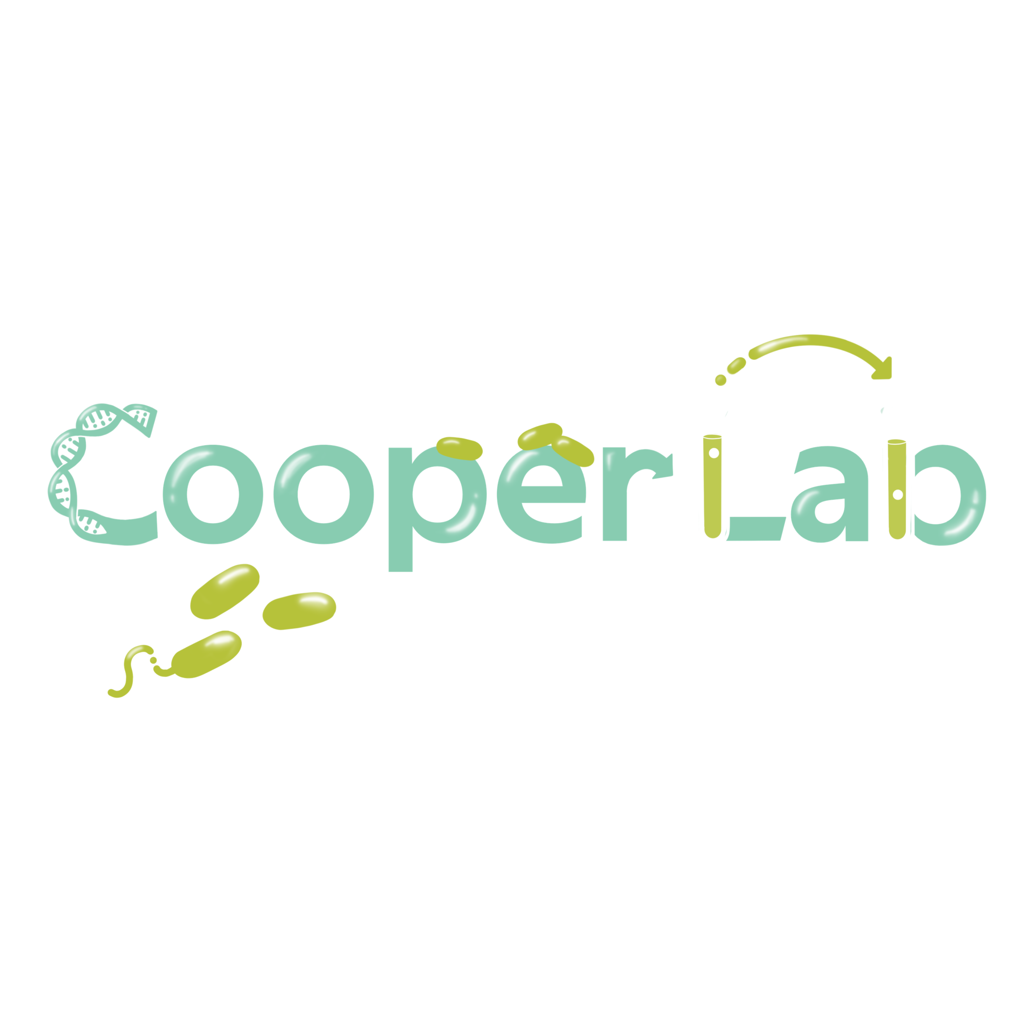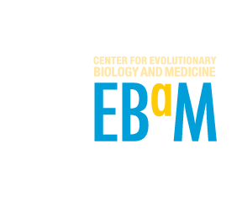
Professor Vaughn Cooper’s laboratory in the Department of Microbiology & Molecular Genetics at the University of Pittsburgh, School of Medicine is recruiting for the following opportunities.

- Postdoctoral scholar to identify and characterize effects of “enabler” mutations that lead to antimicrobial treatment failure in Acinetobacter baumannii and Streptococcus pneumoniae. The scholar will be supported by a NIAID U19 award (CARBIRU) and benefit from training and networking in a multidisciplinary, multi-institution network. This research is motivated by the hypothesis that antimicrobial treatment failure is often caused by genotypes predisposed to tolerance and increased phenotypic variance. These enablers may operate in lieu of or as steppingstones toward classical resistance traits. The collaborative and creative scholar will contribute research using new single-cell methods for lineage tracking and characterizing cellular heterogeneity in collaboration with the van Opijnen (Broad Institute), Isberg (Tufts), and Rosch (St. Jude’s) laboratories. Experience in microbial genetics and being unafraid of the command line is required. A recent representative publication is here.
- Postdoctoral scholar sought for a translational study on the host-pathogen biology of tracheobronchitis in critical illness. The fellow would work on a collaborative, interdisciplinary team determining how changes in the airway microbiota and resulting inflammatory response influence recovery from critical illness using samples from an ongoing cohort study. Expertise desired in the analysis of bacterial genomic data or similar high dimensional data set. A limited amount of wet bench work may be required. Additional desired skills include strong scientific writing skills, basic biostatistics, and a track record of creative problem solving. The position would be co-mentored between the Departments of Medicine (Anna Zemke MD, PhD) and Microbiology/Molecular Genetics (Cooper) with the potential to network within both departments. A recent representative publication is here.

- Educational outreach research assistant to support, develop, and extend implementation of our EvolvingSTEM curriculum in grades 7-12, with a focus on Pittsburgh Public Schools. This revolutionary program enables thousands of students to learn evolution and genetics by conducting an authentic evolution experiment using safe bacteria in their classroom. Major activities for this position include:
  - Training teachers in laboratory skills and supporting their development of new curriculum materials during a summer-long professional development workshop supported by an NSF BIORETS grant
  - Helping teachers implement new curriculum modules in their classrooms
  - Developing and refining new curriculum modules
  - Supporting colleagues conducting assessments of student learning and attitudes towards STEM
  - Ordering necessary supplies and managing assembly of curriculum kits for distribution to schools both locally and nationwide

- Microbial genomics research technician to enable the high-throughput sequencing conducted by our laboratory for our research on the evolution of antimicrobial resistance and persistence in chronic infections. This position provides an outstanding opportunity to gain expertise in high-throughput genomics and make intellectual contributions to projects supported by NIH, NSF, and other funders. Major activities include:
  - Experimental design and execution of microbiological assays including measurements of growth and resistance
  - Preparation of genomic DNA for sequencing, and QC of samples, and construction of libraries using established protocols.
  - Mastery of a workflow for high-throughput sequencing and distribution of results to researchers in and outside of the laboratory.
  - Analysis of experimental data using spreadsheets and scripted statistical methods and sharing with laboratory colleagues.

About the Cooper laboratory:
The mission of the Cooper laboratory is to study evolutionary processes in near real-time in systems with high stakes. These include:
- the causes of treatment failure, when the combined forces of drugs and immunity are ineffective.
- the ecological and population-genetic causes of rapid diversification in microbial biofilms
- novel genetic mechanisms of adaptation to environmental stress
- the biology that underlies our revolutionary EvolvingSTEM curriculum that enables students grades 7-16 to observe and comprehend evolution with a weeklong bacterial evolution experiment.

Our lab uses various in vitro and in vivo models as well as prospective clinical sampling to study these problems, in collaboration with researchers at many leading institutions. We continue to develop new methods and implementations of high-throughput genomics to track the evolutionary process, and we build new analytical tools to enable anyone to resolve evolution-in-action. We also work with experts in science education to measure how our curricula influence learning and attitudes towards careers in STEM.

Why join our team? You have one or more of the following traits:
- A curiosity to understand how adaptations work, and a nose for discovering them
- A passion for sharing the wonder of the evolutionary process with students of all ages
- A commitment to answering some of the greatest challenges in medicine that are problems of evolution, like antimicrobial resistance, cancer, and epidemics
- A willingness to work at the interface of wet-bench experimentation and ambitious bioinformatics, knowing that your teammates span this gamut and can help
- A love of mentorship and a collaborative spirit

